CHAPTER 1

OVERVIEW

* 1. **Introduction**

Conjugated polymers (CPs) are a class of organic semiconducting materials that have been widely studied over the past few decades, owing to their use as active materials for low-cost photovoltaic (PV) and light-emitting diode (LED) technologies.{Dennler, 2005 #10}{Yim, 2008 #56}{McNeill, 2000 #32}{Rothe, 2006 #177} These materials exhibit bright emission in the UV and visible spectrum (fluorescence quantum yields ranging from ~30% to nearly 80%),{Greenham, 1995 #202}{Pei, 1996 #203} as well as efficient energy and charge transport.{McNeill, 2002 #30}{Lunt, 2009 #27} The observed fluorescence emission in the UV-visible spectrum is due to the structure and heteroatoms that comprise each monomer unit, as well as the extended -conjugation along the polymer backbone.{Wu, 2006 #48}{Meier, 1997 #204} To improve upon existing technologies, it is necessary to further understand the disordered, heterogeneous photophysics and energy transport phenomena observed in CP thin films and devices. Specifically, it is beneficial to understand how intrinsic defects and polymer structure and conformation affect these processes. Conjugated polymer nanoparticles (CPNs) exhibit similar photophysics to those of CP thin films, but offer greater control over polymer structure compared to thin films via particle size control. By extension, this provides a more reliable means of controlling nanoscale interactions that lead to heterogeneous dynamics in CPs.

CPNs are also ideal for use in fluorescence imaging applications for a variety of reasons. They possess small (4-30 nm) particle diameters, and are easily functionalized and encapsulated.{Wu, 2010 #53}{Wu, 2006 #178} The photostability figures of merit for CPNs such as ~109 photons emitted prior to irreversible photobleaching and photobleaching quantum yields of ~10-9 are several orders of magnitude better than conventional small molecule dyes and current fluorescent probes. In addition, CPNs exhibit exceptional absorption and fluorescence characteristics, including extinction coefficients of ~109 M-1 cm-1 compared to dyes (~104 – 105 M-1 cm-1), absorption cross sections of ~10-13 cm2, and radiative rates of ~108 photons/s.{Wu, 2008 #51}{Johansson, 1991 #205} Improvements in nanoparticle fluorescence quantum yield and red-shifting of emission are required for effective use in complex biological samples to ensure sufficient signal-to-noise ratios and to overcome background fluorescence inherent in biological media.{Ntziachristos, 2006 #34}

The chapters within this dissertation principally focus on steady-state and time-resolved fluorescence spectroscopy of conjugated polymer nanoparticles and solutions with the goal of better understanding exciton transport in CPNs. In particular, we examine the effect of nanoscale disorder (i.e., the presence of structural and/or chemical defects within CP chains) on the excited state kinetics and spectra of CPNs. We also estimate the exciton diffusion length and exciton diffusion rates in CPNs and linear CPs for optimization of devices based on amorphous organic semiconductors. In addition, we aim to improve the fluorescence characteristics of CPNs (e.g. brightness and red-shifting of emission) for fluorescence imaging applications. Chapter 2 describes the materials, experimental methods, spectroscopic techniques, and instruments utilized in this research. Chapter 3 details the use of dye doping and polymer blending in CPNs with the aim of improving fluorescence brightness and red-shifting emission for fluorescence imaging applications, as well as to estimate the exciton diffusion length while accounting for defects in CPNs. Chapter 4 delineates the use of solvent-induced swelling coupled with time-resolved fluorescence anisotropy decay measurements to determine the rate of exciton transport in undoped CPNs compared to the linear polymer, as well as to assess the reversibility of quenching by defects via swelling. Both projects utilize a combination of steady-state and time-resolved spectroscopy in conjunction with Monte Carlo simulation to address these issues from multiple angles.

* 1. **Conjugated Polymer Device Structure**

Conjugated polymers have been utilized in several device types including photovoltaics and LEDs. Thin films are used in these devices in order to minimize device size and due to the need to layer active materials specifically for electron and hole injection and transport, or as an emissive material layer. In a typical organic photovoltaic (c.f. Fig 1.1), a substrate such as glass is deposited with several thin films, the first being an optically transparent conducting anode material that acts as a hole injection material (e.g. indium tin oxide, ITO). Due to the efficiency of energy transport and hole transport, hole-conducting CPs such as the ones used in this research would comprise the hole transport layer, deposited on top of the cathode. An efficient electron transport layer material (e.g. thiophene polymer, fullerene polymer) is deposited on top of the hole transport layer,[note, actually it often isn’t possible to do the layer-by-layer polymer deposition, because the solvent used for the second layer would dissolve the first. A bulk heterojunction (both polymers mixed and deposited simultaneously) doesn’t have this problem.] and then a metal cathode (typically aluminum) is deposited on top. In these devices, neutral photoexcitations known as Frenkel excitons (described in the next section) propagate to the bulk heterojunction [you are misusing/misunderstanding the concept of bulk heterojunction, see above] where the hole and electron transport materials overlap, and the neutral exciton is separated into individual charges (electrons, holes) via charge transfer. The electron and hole are then transported through the respective transport layers to the cathode or anode, generating electrical current in the device. {Heeger, 2014 #193}{Günes, 2007 #191}{Adams, 1999 #1} Running a similar device in reverse produces light (as charges recombine and excitons decay radiatively), and is the basis of organic LED technology. The efficiency of these devices is determined partially by the work functions of the cathode and anode materials, as well as the efficiency of charge transfer and recombination. Typical power conversion efficiencies for these devices are up to ~9% for PVs, and up to 8% for LEDs.{Dennler, 2005 #10}{Günes, 2007 #191}{Cao, 1999 #192}{Heeger, 2014 #193}

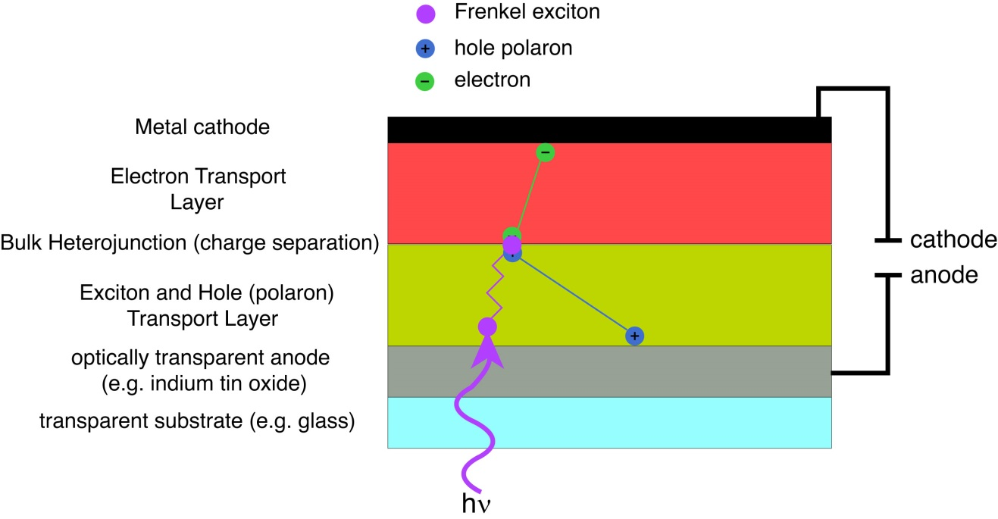

Fig. 1.1. Schematic of a typical organic photovoltaic device depicting exciton generation and exciton, electron, and hole transport.

* 1. **Frenkel Excitons in Conjugated Polymers**

Conjugated polymers possess unique energetic characteristics due to the extended -conjugation (alternating single and double bonds) along the polymer backbone. Upon absorption of a photon, an electron is excited from the  to * electronic band, generating a neutral excitation that is delocalized (through strongly coupled transition dipoles) along a segment of the polymer, known as a Frenkel (or molecular) exciton. This conjugated segment is referred to as a chromophore, which is typically comprised of 2-8 monomer units in CPs and CPNs.

Transition dipole coupling strength determines whether or not excitons form in CPs, as well as ~~chromophore~~exciton size in CPs. Transition dipole coupling ~~also facilitates several types of~~ [is also involved in the typically dominant forms of] energy transport depending on the magnitude of the coupling strength, temperature, and the amount of disorder in the polymer. [What follows is a presentation of a simplified theory for Frenkel-like excitons, based loosely on the theory as presented in a review by Kasha et al.[ref] but omitting several higher-order effects and expressed in more modern notation. Here the discussion is limited to the basic features, key interactions, and some of the key phenomena such as Davydov splitting, “dark” excitons,[better add that if you haven’t] and delocalized excitations or coherent energy transport. More rigorous, extensive, higher-level discussions including many phenomena not discussed here are provided by Silinsh and Capek [ref, I have this book by the way--I forgot to lend it to you] and Pope and Swenberg.[ref]] The interactions between transition dipoles of two or more degenerate ~~monomer units~~chromophores [the way I see it is that pi conjugation between monomer units leads to delocalized electronic wavefunctions (i.e., like the Huckel stuff in p-chem lab) extending over 2+ monomer units and constitute a chromophore. Then the chromophores couple via interactions between transition dipoles. Don’t conflate these two phenomena.] can be described using perturbation theory. The coupling strength is quantified via the perturbation to the energy of the electronic states of the interacting monomers. As a brief review, it can be shown that given a perturbed Hamiltonian $H=H^{(0)}+λH'$ [I usually skip the “lambda” notation in basic textbook perturbation theory, since it is mostly a device to help keep track of the various order-terms and is not typically used by spectroscopists in Frenkel or Fermi Golden Rule discussions/calculations (except maybe in the rare cases where higher-order effects are involved). Rather, I’d use H=H0+Vpert, and E=E0+<Vpert>. You don’t want to get caught up in “useless formalism” because (a) it wastes the reader’s time and (b) it appears that you can’t tell the difference between useless formalism and the key equations/terms. **Also, you should probably number key equations, esp. those that are referred to later.**] that solves the Schrödinger equation $H|\left.ψ\right\rangle ={(E}^{\left(0\right)}+{λE}^{\left(1\right)}+λ^{2}E^{(2)}+…)|\left.ψ\right\rangle$, [skip, see above] where $H^{(0)}$ is the unperturbed Hamiltonian,  ~~corresponds to the amount of perturbation applied, varying between 0 and 1 (taken to be 1 for simplicity),~~ is the perturbation, and the ~~higher-order energy corrections are indicated by their superscripts~~. [note: it might be worthwhile to spend a few sentences and an equation or two discussing the degenerate versus non-degenerate case, since this is essentially what separates heteroFRET, homoFRET and (coherent) Frenkel pictures--if the perturbation is weak relative to the difference in energies for the two sites, then the perturbed states are weakly mixed and the a_k reflect this (one term is close to 1.0 while the other terms are small), whereas for perfect degeneracy and/or relatively strong perturbation, the excitation is spread out and most a_k are small and of similar magnitude, similar to 1/N where N is the # of chromophores.] For degenerate monomer interactions $H^{(0)}|\left.ψ\right\rangle =E_{1}^{(0)}|\left.ψ\right\rangle =E_{2}^{\left(0\right)}|\left.ψ\right\rangle …=E_{D}^{(0)}|\left.ψ\right\rangle$, the first-order enegy correction to the *D* degenerate monomer states is given by $E_{n}^{(1)}=\left\langle n^{(0)} | H' | n^{(0)}\right\rangle =H_{nn}^{'}$, for *n* = 1,2,…D. These corrections correspond to the roots of the corresponding secular determinant given by $\det\left(H_{mn}^{'}-{δ_{mn}E}_{n}^{(1)}\right)=0$ for *n, m* = 1,2,…D where $E_{1}^{(1)}≠E_{2}^{(1)}…≠E_{D}^{(1)}$ (if the degeneracy is removed completely in first-order), and it is assumed that the correct zero-order wavefunctions $|\left.n^{(0)}\right\rangle =\sum_{k=1}^{D}{a_{k}|\left.k\right\rangle }$ that diagonalize the secular determinant are used.{Levine, 2000 #182} Thus, the perturbation acting on a set of degenerate electronic states results in either partial or complete splitting of the previously degenerate energy levels of the individual monomers sharing the excitation (Davydov splitting),[ref ] which leads to energy shifting of the UV-Vis and fluorescence spectra of CPs in the nanoparticle or thin film state due to interchain and/or intrachain interactions [as well as changes in the transition strength]. In the simplest case of two identical ~~interacting~~ monomers [interacting through their transition dipole moments], the first-order energy corrections $H_{11}^{'}{=E}_{1}^{(1)}$ and ${ H_{22}^{'}=E}_{2}^{(1)}$ are $±V_{dd}$, respectively, where $V_{dd}$ is the dipole-dipole interaction potential, which is proportional to *R*-3, where *R* is the intermolecular separation.

Excitons are able to migrate along or between polymer chains via several processes, including incoherent processes such as Förster resonance energy transfer (FRET) and Dexter electron transfer (described in detail in section 1.4), or by coherent energy transfer; all of these processes encompass what is often referred to as “exciton diffusion,”{Scholes, 2006 #36} or multiple energy transfer. These terms will be used interchangeably in this dissertation; however, the latter term arises from the assumption that most of the observable exciton transport at or above the picosecond time scale is due to incoherent energy transfer processes, and thus progresses as a series of multiple discrete energy transfer events. Nevertheless, understanding coherent transfer is critical to understanding the nature of excitons and exciton diffusion in conjugated polymer systems.

Coherent energy transfer is understood upon calculation of the time-dependent probability of an electron tunneling from one monomer to another. For the aforementioned two-molecule system, the probability amplitude of an electron tunneling from a molecule in state $|\left.a\right\rangle$ to a degenerate molecule in state $|\left.b\right\rangle$ is given by $A\left(t\right)=\left\langle b | exp⁡(iHt/ℏ) | a\right\rangle =(1/2)[exp⁡(iωt)-exp⁡(-iωt)]=isin\left(ωt\right)$, [break this out on a line by itself and number it. I’m referring to it as Eq X below.] where $ω=V_{dd}/ℏ$, and $ℏ$ is the reduced Planck constant $h/2π$. The resulting tunneling probability is given by ${|A(t)|}^{2}=\sin^{2}(ωt)$. Thus, the probability of finding the excited state electron on one of the participating monomers oscillates back and forth between the coupled monomer units with a tunneling (energy transfer) rate constant of $k_{tun}=k_{et}=V_{dd}/ℏ$. This tunneling process occurs on the femtosecond time scale, and ~~is the basis of exciton diffusion~~ [represents the strong coupling or coherent limit and is a good approximation as long as thermal disorder and energetic disorder are low relative to the coupling strength.]. Given a set of monomer units (or chromophores) with strongly coupled transition dipoles, an excitation on one of the monomers will yield an oscillating excitation across the set of interacting monomers (or the set of chromophores). [Förster transfer between identical chromophores involves the same basic physical picture, but thermal or energetic disorder breaks up the coherence and the mixing of the states (introduces additional frequencies in Eq. X), and the resulting transport process is better described as excitation localized on a single chromophore undergoing hopping via an incoherent process.] The relative contributions of FRET, Dexter transfer, and coherent transfer can be understood by the ratio of $V_{dd}/k_{B}T$, where $k_{B}T$ is the Boltzmann constant times temperature. For systems with $V_{dd}/k_{B}T≫$ 1, exciton formation dominates, and coherent transfer is the primary means of energy transport. For systems where $V_{dd}/k_{B}T≪$ 1, neighboring monomers (and chromophores) do not interact strongly, thus limiting chromophore size and/or coherent transfer between like chromophores.{Kasha, 1963 #186}{Köhler, 2011 #194} It is important to note that Dexter transfer and FRET between like chromophores (homo-FRET) still contributes to exciton transport for all coupling strengths [why is this important? I disagree. Rather, I would say that the underlying physical picture and interactions are the same for homo-FRET and the Frenkel picture, see above comments.]. For low coupling strengths, homo-FRET and/or Dexter transfer dominate, depending on the degree of molecular orbital overlap and alignment of transition dipoles. However, for high coupling strengths, the contributions of FRET and Dexter transfer are smaller by comparison.{Kasha, 1963 #186}{Athanasopoulos, 2013 #3}

[As mentioned above, ] temperature and disorder in CPs and CPNs also affect the rate of exciton transport. At high temperatures (e.g. room temperature) excitons are thermally activated [what does that mean??], leading to exciton-phonon coupling, which blue shifts emission, and increases the exciton diffusion length LD (i.e., the average distance travelled by an exciton during its excited state lifetime, discussed in detail in chapter 3). Reducing temperature (<150 K) eliminates thermal phonon absorption, reducing the number of available states for an excitation to transfer to, causing frustrated exciton transport. In addition, the emission is red-shifted, since subsequent energy transfer steps can only occur to lower energy sites in the absence of exciton-phonon coupling.{Athanasopoulos, 2013 #3}{Mikhnenko, 2015 #195}{Meskers, 2001 #196} [Is this classic/typical thermal behavior in excitonic systems, or did you get sidetracked by a few papers about some oddball systems? A perhaps more typical picture is that at RT the coherence of excitons is broken up due to thermal disorder, and transport is mostly via incoherent, phonon-assisted processes, whereas at lower T coherent exciton transport dominates.] Disorder in CPs is defined as the presence of conformational defects or chemical defects along CP chains.[I find these statements useless/confusing/frustrating. Is this the standard definition? Is this the definition you are asking the reader to adopt, temporarily, for the purpose of this discussion? Why is it important to define it in this way? Why not just say what you mean to say rather than forcing the reader to swallow a bunch of dodgy/dubious/debatable redefinitions first for no apparent reason? Suggested fix: “conformational variability and/or chemical defects in the CP chain give rise to energetic disorder that can affect various excited state processes as well as lead to shifts in emission spectra”] Conformational disorder (structural defects, i.e. bends or kinks in the polymer chain) arise most commonly in aggregated CP samples such as nanoparticles or thin films, whereas chemical defects in CPs are often the result of oxidation of the polymer (e.g. fluorenone/keto defects in polyfluorenes).{Hintschich, 2003 #19} [or side products in the polymerization reaction] The presence of various defects result in conjugation breaks along CP chains, which in turn yields inhomogeneous broadening of optical spectra due to the distribution of exciton energies associated with a random distribution of conjugation lengths within the polymer. {Dias, 2006 #197} Disorder also broadens the distribution of fluorescence lifetimes within CPs and CPNs, leading to fluorescence intensity decays characterized by complex exponential functions.

**1.3.1 ~~Competing~~ Exciton Decay Processes in CPs**

In addition to the exciton diffusion processes mentioned above, there are various competing decay processes in CPs and CPNs that determine the fate of a given exciton after photon absorption (c.f Fig 1.2).

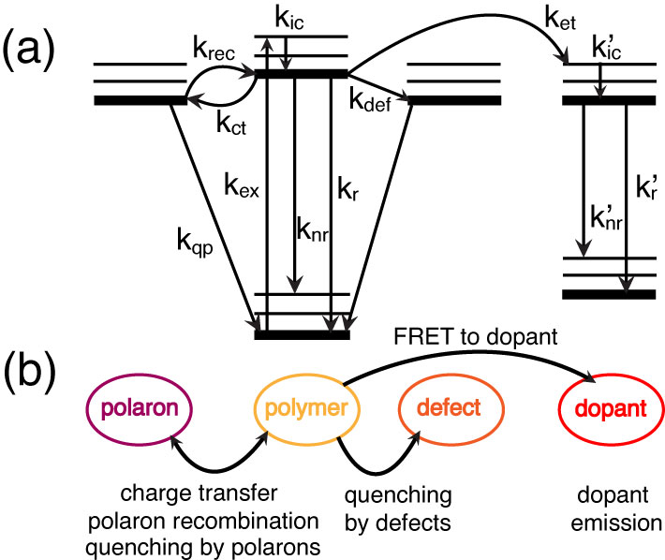

Fig. 1.2. (a) Jablonski diagram illustrating the competing rate processes in doped CPNs. (b) Illustration relating the rate processes in (a) to their respective physical observables.

After ~~internal conversion~~ vibrational relaxation [You had it backwards: internal conversion is the conversion of electronic energy to vibrational energy, whereas vibrational relaxation is the loss of excess vibrational energy while staying in the same electronic state. Don’t get this wrong on a job interview!! This is one of those cases where Wikipedia gets it right, https://en.wikipedia.org/wiki/Internal_conversion_(chemistry) although they use the phrase “vibrational deactivation” in the diagram. The page on vibrational (energy) relaxation also gets it right: https://en.wikipedia.org/wiki/Vibrational_energy_relaxation] to the ground vibrational state of the excited electronic state (kic), an exciton may either decay radiatively (kr) or non-radiatively (knr) [via internal conversion]. The exciton may [also?] undergo Förster resonance energy transfer (FRET) to a defect site (kdef) where the exciton is quenched. Excitons may undergo charge transfer to form hole polarons (kct, discussed later), or the hole and electron recombine to reform the neutral exciton (krec). If subsequent excitons are generated in the vicinity of a polaron, they may be quenched by the polaron (kqp). If a dopant species is introduced into the system, an exciton may undergo FRET to the dopant (ket, discussed below), where similar processes apply if the dopant is a conjugated polymer, or radiative and non-radiative decay may occur if a fluorescent dye dopant is used.

* 1. **Förster Resonance Energy Transfer (FRET) and Dexter Electron Transfer in CPs**

FRET and Dexter electron transfer are processes involving the transfer of an electronic excitation from molecule to another. If transfer occurs between like molecules (e.g. equivalent chromophores of a conjugated polymer), this is referred to as homotransfer or homo-FRET. If transfer occurs between chemically distinct molecules, this is referred to as heterotransfer. For either transfer process, the molecule initially excited by photon absorption to its singlet excited state is referred to as the donor, and the molecule that the excitation is transferred to is referred to as the acceptor. Both processes are non-radiative (there is no photon emission upon donor relaxation nor reabsorption of emission resulting in acceptor excitation), and have similar initial and final states. However, the path by which an excitation moves from one molecule to another differs. The differences between each process are discussed in detail below, and illustrated in Fig. 1.3.

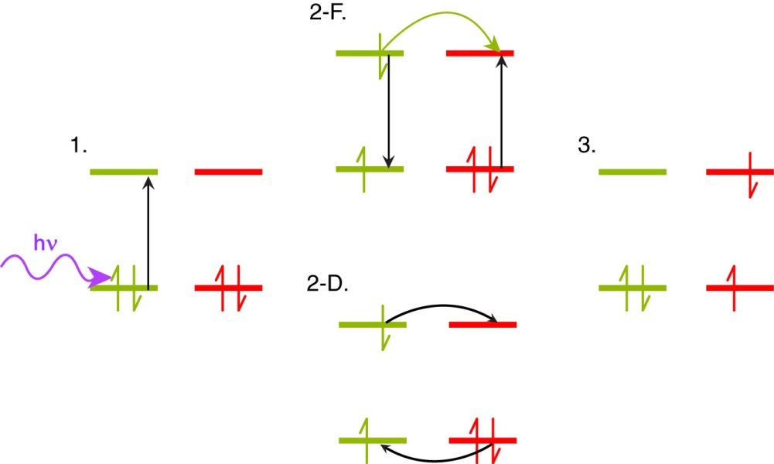

Fig. 1.3. Comparison of Förster and Dexter transfer, including illustration of the HOMO and LUMO orbitals of a donor (yellow) and acceptor (red) pair, with colored arrows to indicate photon absorption (purple), energy transfer (yellow), and electron motion (black). In the initial state (1), a HOMO donor electron is excited to the LUMO via photon absorption. The intermediate states illustrate the Förster resonance energy transfer (2-F) and Dexter electron transfer (2-D) processes. Both processes yield the same final state with the donor in the ground electronic state an electron in the acceptor LUMO (3).

The process of FRET involves long-range (≤10 nm) transition dipole coupled energy transfer from the donor to the acceptor, resulting in non-radiative relaxation of the donor electron from the excited state back to the ground state, and concomitant HOMO🡪LUMO excitation in the acceptor.{Förster, 1948 #181} The FRET process is dependent upon several variables, including intermolecular separation, spectral overlap of the donor fluorescence spectrum with the acceptor absorption spectrum, and relative alignment of transition dipole moments between the donor and acceptor. It is convenient to define a distance *R*0 known as the Förster radius, where FRET between the donor and acceptor is 50% efficient (typically 1-6 nm).{Wiczk, 1991 #206}{Akrap, 2010 #207} This is given by the equation

, (1.1)



where *n* is the refractive index of the solvent, *N* is Avogadro’s number, *D* is the fluorescence quantum yield of the donor (a measure of the percentage of photon absorption events that result in fluorescence photons). **2 is the transition dipole orientation factor (typically assumed to be 2/3 for random transition dipole orientations), given by

, (1.2)



where the angle ** corresponds to the angle between the donor and acceptor transition dipole vectors, ** corresponds to the angle between the donor transition dipole vector and the intermolecular axis, and ** corresponds to the angle between the acceptor transition dipole vector and the intermolecular axis (c.f. Fig 1.4).

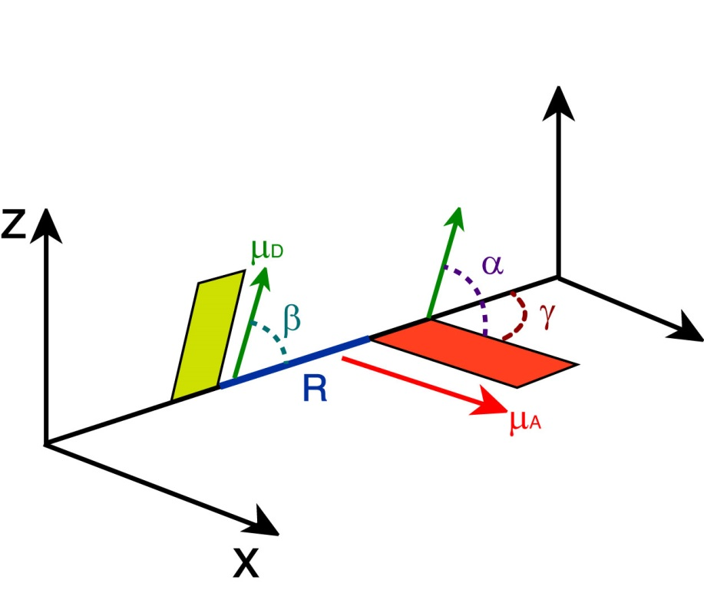

Fig. 1.4. Illustration of transition dipole vectors and angles used to calculate **2 for a donor and acceptor pair. D (green) and A (red) correspond to the donor and acceptor transition dipole vectors, R (blue) is the intermolecular distance along the intermolecular axis.

Lastly, *J*(**) is the spectral overlap integral, calculated by

, (1.3)



where ** and *d* are the wavelength and wavelength spacing, respectively, *FD*(**) is the normalized emission spectrum of the donor, and *A*(**) is the extinction spectrum of the acceptor (converted from the absorption spectrum using Beer’s Law). The energy transfer rate constant (*ket*) is determined using the Förster radius by

, (1.4)



where *R* is the intermolecular separation and 0 is the fluorescence lifetime of the donor. FRET is a useful tool for measuring interactions between molecules for distances <10 nm, and is often referred to as a “molecular ruler.”{Stryer, 1967 #172}{Stryer, 1978 #173}{Lakowicz, 2006 #26}

The dependence of the FRET rate constant on the inverse sixth power of intermolecular separation arises initially from the fact that FRET is facilitated by interacting excited-state transition dipoles, whose interaction potential $V_{dd}$ is proportional to *R*-3 (taken to be a first-order perturbation between the excited donor and acceptor). The distinction of Förster transfer from previously mentioned coherent transfer is that Förster transfer is assumed for very weakly coupled transition dipoles, whereas coherent transfer requires strong coupling. From the time-dependent tunneling example described in section 1.3, we see that the tunneling probability amplitude $A\left(t\right)=isin(ωt)$. We can approximate the sine function at early times as $A(t)≅iωt$ and thus ${|A\left(t\right)|}^{2}≅ω^{2}t^{2}≅{(V_{dd}t/ℏ)}^{2}$, which yields an *R*-6 proportionality in the tunneling rate.

Despite sharing the same initial and final states with regard to donor and acceptor as FRET, the mechanism of Dexter transfer differs substantially from FRET. In Dexter transfer, an electron in the ground state (HOMO) of the acceptor is exchanged with an electron in the excited state (LUMO) of the donor. These electrons possess identical spins, and remain in similar electronic states (a LUMO donor electron is transferred to the LUMO of the acceptor, and a HOMO electron in the acceptor is transferred to the HOMO of the donor). The spin criterion holds true for singlet Dexter transfer, but not for triplet transfer, or triplet-triplet annihilation,{Monguzzi, 2008 #180} in which the transferred electrons possess opposite spins. The Dexter process is facilitated by molecular orbital (wavefunction) overlap, as well as spectral overlap of the donor fluorescence spectrum with the acceptor absorption spectrum. Given the former criterion, the Dexter transfer mechanism is very sensitive to changes in intermolecular separation. The distance-sensitivity of Dexter transfer is made clear upon inspection of the probability of electron exchange, given by:

, (1.5)



where *Z* is a constant (1), *J*(**) is the is the normalized spectral overlap integral given by Equation 1.3, *R* is the intermolecular separation (in angstroms), and *L* is the average of the van der Waals radii of the donor and acceptor (in angstroms). {Dexter, 1952 #176} Inspection of the exponential term alone in Equation 1.5 elucidates the distance sensitivity of Dexter transfer. Depending on the average van der Waals radius *L*, the probability of electron exchange falls to [essentially] zero within ~1-2 nm or less, and is reduced further depending on the spectral overlap and *Z*, proving that Dexter transfer is only efficient at very small intermolecular separations. [However, for cases in which chromophores are tightly packed and Förster transfer is not favored (for example, due to unfavorable dipole alignment, or in the case of triplet excited states, which exhibit low acceptor extinction), Dexter may be the dominant energy transfer mechanism.[ref: IIRC Fleming had a paper on this, or at least on the effect of wavefunction overlap in LHC or related system]]

* 1. **Polarons in Conjugated Polymers**

Devices based on CPs require efficient charge transport in addition to efficient exciton transport in order to function properly. In these devices, charges are either injected into the polymer through cathode/anode materials, or formed by dissociation of excitons through charge transfer events at the ~~bulk~~ heterojunction (c.f. section 1.2). Additionally, many fluorescence measurements on conjugated polymers and nanoparticles are complicated by photoejection of charges at higher excitation powers, resulting in a leftover isolated charge on the polymer chain that quenches the excited state via charge-transfer complexation, or damages the polymer resulting in photobleaching. These isolated charges along with the polarized volume surrounding them within the polymer are treated as quasiparticles and referred to as polarons.

The majority of measurements performed in this research were performed in air, and thus the presence of oxygen provides an oxidizing environment. This is combined with the fact that under ambient conditions, the CPs used in this study are inherently hole-conducting/electron donating. As such, hole polarons are assumed to be the prominent type of polaron occurring in these CPs. However, under reducing conditions, or by using intrinsically electron-conducting conjugated polymers such as polythiophene or CPs based on fullerenes such as PCBM, electron polarons can be more prominent.{Brabec, 2001 #200}{Bakalis, 2014 #201} Hole polarons can recombine with electrons to reform Frenkel excitons, and the combined processes of exciton dissociation and charge recombination lead to blinking phenomena in CP single molecules, thin films, and CPNs. {Barbara, 2005 #198}{Yu, 2012 #58}{Lin, 2008 #199} The reduced energy of hole polarons leads to red-shifting of emission resulting from polaron recombination and radiative exciton decay. [???I think you got this wrong or it came out different than intended]. Polarons are able to quench ~90% of the fluorescence of a CP chain consisting of ~103 chromophores, and they can possess quenching volumes as high as ~400 nm3, making them extremely efficient fluorescence quenchers. {Yu, 2004 #171}{Yu, 2012 #58} In addition, polarons can diffuse throughout the conjugated polymer medium ~~in a manner similar to incoherent exciton transport, partially due to spectral overlap between the conjugated polymer and polaron~~.[, since conjugated polymers are disordered semiconductors]. The localized quenching behavior of hole polarons combined with polaron diffusion also allows for tracking of charge carrier motion in CPNs, {Yu, 2012 #58}{Yu, 2009 #57} and can be utilized to determine the rates of polaron generation and recombination in CPNs via determination of blinking rates using single molecule fluorescence microscopy.

* 1. **Aggregate Species in Conjugated Polymer Nanoparticles**

Conjugated polymer nanoparticles are comprised of one or more collapsed CP chains. Structural defects introduced upon chain collapse (e.g. bending/kinking of the polymer backbone) break up the conjugation along the polymer backbone, causing differences in the emission characteristics of each conjugated segment. This contributes to the broad fluorescence spectra and lifetime heterogeneity observed in CPNs. In addition to the structural defects introduced upon chain collapse, -stacking interactions between many closely spaced chromophores lead to the formation of aggregate species. These aggregate species can be in the form of H- or J- aggregates, excimers, or exciplexes.{Hayer, 2012 #18}{Jelly, 1936 #21}{Jenekhe, 1994 #183} These interacting species are given in detail below, and summarized by their structural and spectroscopic characteristics in Table 1.1.[Somewhere it should be noted that the H- and J- aggregate picture is really an aspect of the Frenkel exciton picture, as in the cume problem I gave on the subject.]

The differentiating characteristics between H- and J-aggregates are their structural alignments, spectral shifts that arise from transition dipole orientations, and fluorescence lifetimes. Although H- and J-aggregates both arise from $π$-stacking of monomers,[no! See above.] they differ in their exact structural alignment by their “slippage angle.” This is the angle formed by the long axis of one molecule, and the line connecting the centers of the molecules. For high slippage aggregates (angles 0°–54.7°), the transition dipoles are aligned in a head-to-tail orientation, which leads to J-aggregate spectral characteristics. For low slippage aggregates (angles 54.7°–90°), the transition dipoles are in parallel orientation, leading to H-aggregate spectral characteristics (c.f. Fig 1.5).{Wurthner, 2011 #140} In H-aggregates, the absorption and fluorescence spectra are shifted toward higher energy (hypsochromically shifted or blue-shifted) and the emission spectrum is broadened. The lifetimes of H-aggregates are also either similar to or longer than that of the monomer.{Clark, 2007 #189}{Maiti, 1997 #187}{Chaudhuri, 2011 #188} In contrast, J-aggregates exhibit bathochromically shifted (shifted toward lower energy or red-shifted) absorption and emission, with a narrowing of the emission band and an increase in fluorescence quantum yield, and a substantial reduction in lifetime compared to the monomer. (While Scheibe and Jelley both independently discovered J-aggregates in the same year, Jelley is formally credited for their discovery through their nomenclature).{Jelly, 1937 #21}{Scheibe, 1937 #185}{Wurthner, 2011 #140}{Kometani, 2000 #24}[…and Frenkel developed the quantum-mechanical description] The energy shifting in H- and J-aggregates results from exciton formation (c.f. Section 1.3) between the aggregated chromophores resulting in Davydov splitting into a higher and lower energy state relative to the degenerate monomers. Calculating the transition dipole moment for the higher and lower energy states in each case determines the optically allowed transitions for both aggregate species. The allowed transition for each case is the transition to the higher energy state of an H-aggregate, and the lower energy state of a J-aggregate. These states correspond a nonzero vector sum of transition dipoles (parallel transition dipole arrangement for H-aggregates, head-to-tail arrangement for J-aggregates), whereas the opposite states yield transition dipole vector sums of zero (antiparallel transition dipole arrangement for H-aggregates, head-to-head transition dipole arrangement for J-aggregates).{Köhler, 2015 #184}{Kasha, 1963 #186}

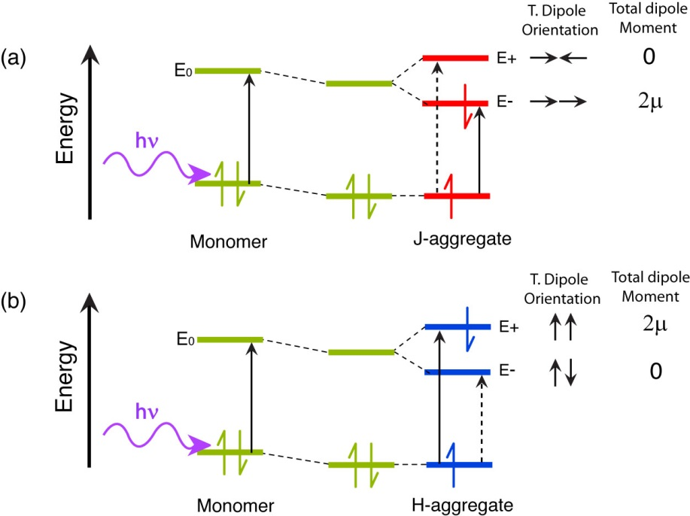

Fig 1.5. Molecular orbital illustration of (a) J-aggregate and (b) H-aggregate states. Transition dipole coupling stabilizes the dimer. The allowed transitions for each aggregate are given by the solid black arrow, and forbidden transitions are given by a dashed black arrow. Transition dipole orientations and total dipole moments are given to the right of each M.O. diagram.

Unlike H- and J-aggregates, excimers (excited dimers) and exciplexes (excited complexes) both result from an interaction of one molecule in its excited state with another molecule in its ground state. The differentiation between the two is that excimers result from RET interactions of like molecules to form an electronically neutral dimer (similar to H- and J-aggregates), whereas exciplexes result from electron transfer interactions between two chemically distinct molecules resulting in a charge transfer complex with a net zero charge.{Köhler, 2015 #184} The main factors that impact whether excimers or H- and J-aggregates form includes the structural arrangement of the molecules, and the relative transition dipole coupling strength between the interacting monomers. Excimers and H-aggregates form under similar structural arrangements; however, unlike H-aggregates, excimers are identifiable by a red-shift of emission due to the stabilization of the dimer upon formation, and a substantial reduction in fluorescence lifetime.[wrong. excimers have a “dissociated” ground state. Also, in addition to being red-shifted, they are very broad and structureless (no vibronic structure)--the transition is between a bound excited state that has a typical bound state E vs R curve, and a dissociative ground state that looks like a hyperbola--ask me to sketch it if you don’t understand and can’t find a reference/sketch] Compared to H-aggregates, excimers also require stronger transition dipole coupling in order to form, and as such, complete cofacial molecular configuration is favored.{Köhler, 2015 #184}[I don’t think this is generally true, or relevant/important. I think the key feature is the dissociative ground state, as discussed above] Exciplexes are formed by electron transfer between two chemically distinct molecules, where the excited electron donor becomes positively charged, and the electron acceptor becomes negatively charged, resulting in coulombic attraction to form the exciplex. Exciplexes share similar lifetime characteristics to H-aggregates,[really? I thought exciplexes can be much longer-lived in some cases, but I could be wrong. I also thought the PLQY is typically much lower for exciplexes] but like excimers, exciplexes exhibit red-shifted emission due to energetic stabilization of the charge-transfer complex.{Köhler, 2015 #184}{Jenekhe, 1994 #183} Due to the conditions required for efficient electron transfer (c.f. section 1.4), exciplexes form most efficiently for cofacial arrangements of donor and acceptor, maximizing molecular orbital overlap. Exciplexes also tend to be favored in nonpolar solvents, as polar solvents stabilize the interacting charges leading to solvent-separated ion pairing and exciplex quenching.{Ghoneim, 2001 #190}

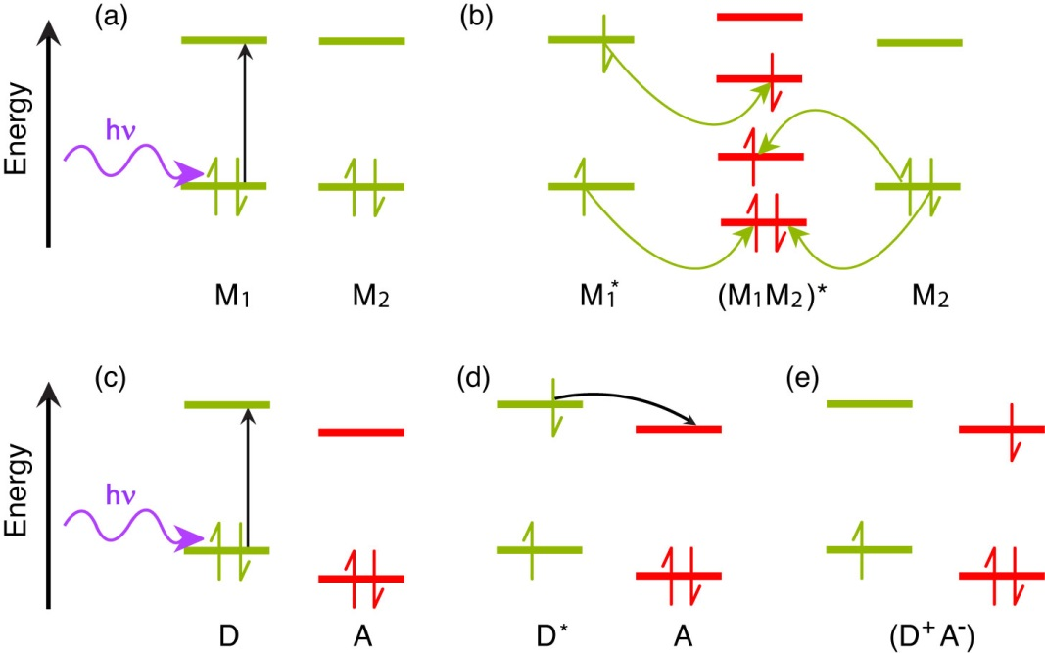

Fig. 1.6. Molecular orbital illustration of excimer (a, b) and exciplex (c-e) formation. In the excimer case, two like molecules M1 and M2 interact, with (a) M1 initially excited to M1*, followed by (b) RET (yellow arrows) to form a neutral excited dimer (M1M2)*. In the exciplex case, two distinct molecules, one electron donor D and one electron acceptor A interact. (c) The donor is excited from D to D*, followed by (d) electron transfer (black arrow) from D* to the acceptor A to form an excited state charge-transfer complex (D+A-).{Köhler, 2015 #184}[note: it might be good to have some illustrations of how the molecules are oriented]

|  |  |  |  |
| --- | --- | --- | --- |
| **Aggregate**  **Species** | **Spectral**  **Signature** | **Lifetime**  **Characteristics** | **Structural Arrangement (slip)** |
| H-aggregate | Broad, blue-shifted spectra | Lifetime $≥$ monomer lifetime | 54.7°–90° |
| J-aggregate | Narrow, Red-shifted spectra | Lifetime << monomer lifetime | 0°–54.7° |
| Excimer | Broad, Red-shifted spectra | Lifetime << monomer lifetime | ~90° |
| Exciplex | Broad, Red-shifted spectra | Lifetime $≥$ monomer lifetime | ~90° |

Table 1.1. Summary of aggregate species, spectral signatures, lifetime characteristics, and monomer structural arrangements expressed as slippage angles.

* 1. **Fluorescence Anisotropy Decay in Conjugated Polymer Nanoparticles**

Exciton transport in conjugated polymers and nanoparticles is the result of multiple energy transfer events between chromophores that are more or less indistinguishable from one transfer event to the next. It is of particular interest to understand how nanoscale structure (polymer in solution versus nanoparticles) affects the rates of exciton transport in CPs. While steady-state UV-Vis and fluorescence can help to elucidate significantly different species in the ensemble via their spectral signatures (e.g. H-/J-aggregates, chemical defects), and lifetime measurements allow for the calculation of decay rates for each distinguishable part of the ensemble, it is not possible to determine average energy transfer rates between equivalent chromophores using these methods. Fluorescence anisotropy is used as a means to quantify the polarization of the emission of a fluorophore after being excited by plane-polarized light. Typically, the excitation source is vertically polarized, and the emission is analyzed after being passed through a linear polarizer oriented parallel (0°) or perpendicular (90°) relative to the excitation source. These components of the emission are given by and , respectively, and the anisotropy *r* is then calculated by



, (1.6)



which forms a ratio of the difference between the parallel and perpendicular emission components relative to the total intensity. Extending this into the time domain, 1.6 becomes

, (1.7)



where *r*(*t*) is the fluorescence anisotropy decay (FAD), and and are the respective fluorescence intensity decays collected at 0° and 90° polarizer orientations. FAD allows us to quantify the rate at which different processes (e.g. rotation, multiple energy transfer) cause depolarization of the fluorescence signal. It is worth noting that the relative amplitude of cos2** and sin2**, where ** is the angle of the emission polarizer. When the emission polarizer is set to  = 54.7° (magic angle, ~55°), this results in cos2** = 0.333 and sin2**  , which corresponds to a twofold amplitude of the perpendicular component of the emission relative to the parallel component of the emission, or .{Lakowicz, 2006 #26} Thus, it is possible to measure the total intensity *S*(*t*) by magic angle orientation of the emission polarizer, and the anisotropy decay is calculated by



. (1.8)



Structural defects[I’m not sure if this is the right phrase--“structural (or conformational) disorder” maybe?] in CPNs result in many closely-spaced chromophores in varied orientations in space. Thus, it follows that a linearly polarized excitation source (e.g. a pulsed laser) would preferentially excite certain chromophores (those with their transition dipole moments oriented similarly to the polarized excitation pulse). In an aqueous suspension of CPNs, particles are typically large enough that rotational diffusion at room temperature occurs on time scales several orders of magnitude slower than the lifetime of the nanoparticles (rotational correlation times are tens of ns to µs, depending on particle size, whereas CPN lifetimes are typically on the picosecond time scale), which allows the assumption that any depolarization of fluorescence can effectively be ascribed to energy homotransfer events. As previously discussed, exciton homo-transfer on the ps-ns time scale is typically driven by incoherent methods of energy transfer (e.g., FRET, Dexter transfer). Given that the interchromophore distance is minimal (~1 nm) and assuming sufficient spectral overlap, the efficiency of each energy transfer event is then essentially governed by the alignment of transition dipole moments, accounted for in the 2 term in equation 1.1, which need not be perfectly aligned for energy transfer to occur. Therefore, each energy transfer event ~~slightly~~ depolarizes [I think it is more than slight] the resulting emission (c.f. Fig 1.7). The rate of depolarization, and thus the rate of exciton motion can be probed using picosecond fluorescence anisotropy decay.[stopped kind of abruptly. Maybe putting in context of exciton diffusion length, number of ET events that occur within the excited state lifetime and the typical distance per event, effective chromophore size ]

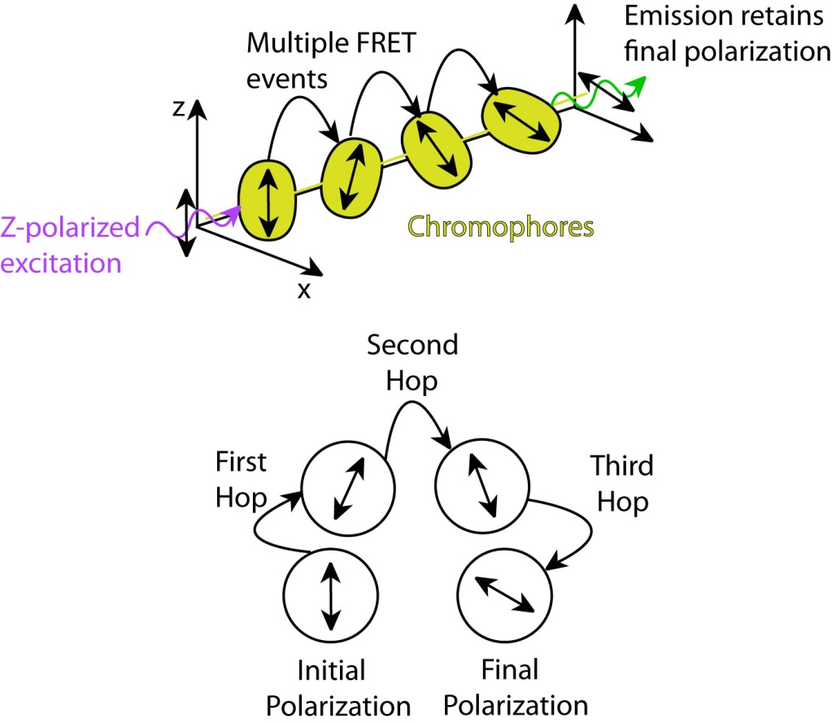

Fig. 1.7. (top) Diagram depicting polarization loss via multiple energy transfer. (bottom) Illustration of polarization changes after each FRET event.